

Dynamics 365 Manufacturing Accelerator Supplier Portal

Installation Guide

**Published**: May 2020

**Accelerator Release Version**: May 2020

Table of Contents

Introduction 3

Prerequisite Files 3

Main Solutions 3

Additional Solutions 3

Installation Steps 4

Manually Import Main Solutions 4

Provision the Portal 4

Import Additional Solutions with Configuration Migration Tool 6

Update Website Binding 7

Portal Authentication Configuration 8

Prerequisites 9

Power BI Integration 13

Prerequisites 13

Model Driven App 13

Portal 14

Reference 15

Data Migration Utility (Configuration Migration) 15

# Introduction

The purpose of this document is to provide a guide on installing and configuring Dynamics 365 Manufacturing Accelerators Supplier Portal solution.

# Prerequisite Files

Make sure the following solutions are installed already (1) Dynamics 365 Manufacturing Accelerator (2) Dynamics 365 Manufacturing Accelerator Model Driven App by following the *Dynamics 365 Manufacturing Accelerator Base Solutions Installation Guide V1.docx* document.

# Main Solutions

For a list of all entities and attributes, find the Manufacturing Reference Guide amongst the included documentation. To import, follow steps in the “Manually deploy Main Solutions” section below. Solutions must be installed in the following order:

1. Dynamics365ManufacturingAcceleratorPortal
   1. Name: Dynamics365ManufacturingAcceleratorPortal
   2. Description: This solution contains Supplier Portal customization, which includes supplier on-boarding and electronic communication configuration. It also includes workflow, processes and power automate to support business scenarios which needs to be trigger.
   3. Dependencies:
      1. Dynamics365ManufacturingAccelerator
      2. Dynamics365ManufacturingAcceleratorModelDrivenApp

# Additional Solutions

The solutions contain Sample Data for the Supplier Portal.

1. Dynamics 365 Manufacturing Accelerator Portal Data
   1. Name: Dynamics365ManufacturingAcceleratorPortalData.zip
   2. Description: The data package contains data related to portal configurations.
   3. Dependencies:
      1. Make sure the Common data service for starter portal is installed.
      2. Ensure that the all the solutions mentioned above under “**Main Solutions**” are imported.

# Installation Steps

## Manually Import Main Solutions

To manually import a main solution:

1. Navigate to <https://make.powerapps.com/home> > Select your Environment > Click Solutions in left-hand Navigation.
2. Click Import button in ribbon.
3. Click Choose File button and select managed solution zip file under main solution heading one by one.
4. Click Open button.
5. Click Next through all steps and then Import.

## Provision the Portal

1. Sign in to [Power Apps](https://make.powerapps.com/).
2. Under **Make your own app**, select **Portal from blank**.
3. If the selected environment does not contain portal pre-requisites, a message is displayed in the **Portal from blank** window suggesting you select another environment or create a new one.

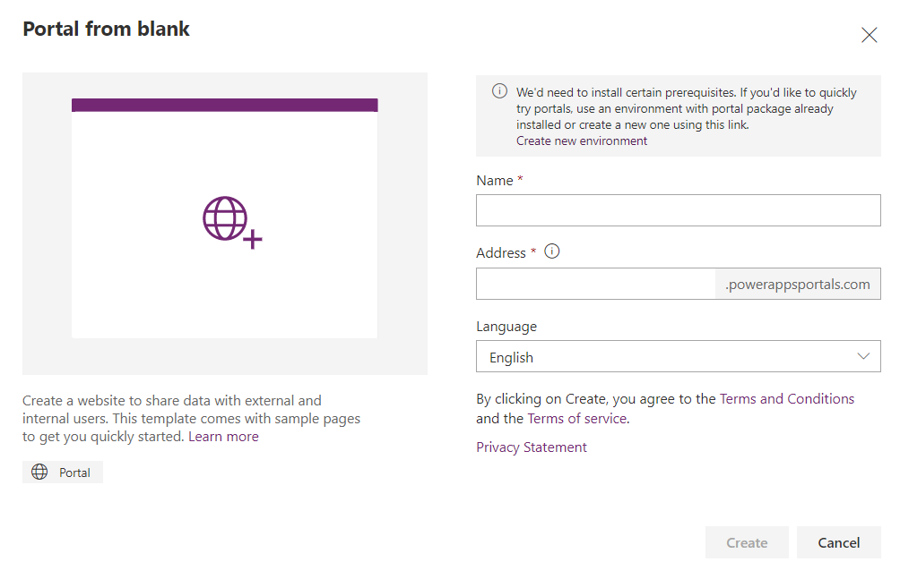

1. In the **Portal from blank** window, enter a name for the portal and address for the website, and select a language from the drop-down list. When you are done, select **Create**.

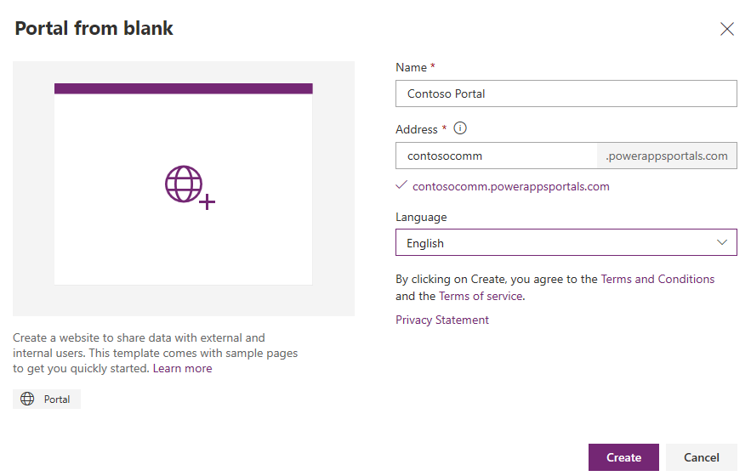

After you select **Create**, the portal will begin provisioning and the provisioning status is displayed through [notifications](https://docs.microsoft.com/en-us/powerapps/maker/portals/create-portal#portal-provisioning-notifications).

If you have created your portal in the environment that does not have portal pre-requisites installed, the provisioning status is also displayed in the grid:

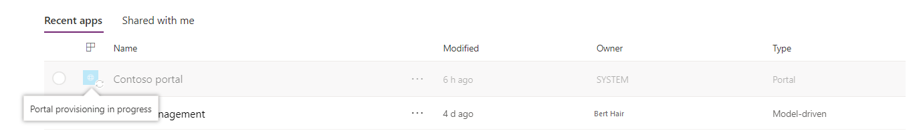

After the portal is provisioned successfully, the status is updated, and the portal is displayed in the grid:

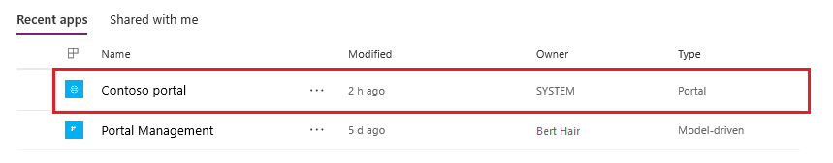

1. Select More Commands (...) > Settings.

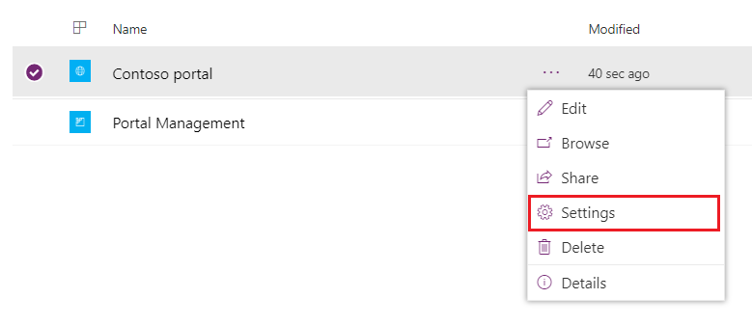

For more information on this, see [this guide](https://docs.microsoft.com/en-us/powerapps/maker/portals/create-portal).

## Import Additional Solutions with Configuration Migration Tool

To Import an additional solution using the Configuration Migration Tool:

1. Open “Configuration Migration Tool” folder (**Note:** Make sure folder is on Desktop so directory name is short). In order to download this tool, see heading “**Data Migration Utility (Configuration Migration)**” below in the document.
2. Open the new “Tools” folder, then “ConfigurationMigration”, and run “DataMigrationUtility”.
3. To Import:
   1. Select “Import Data”.
   2. Connect to the org to import the data to.
   3. Select the appropriate data zip file along with
   4. Perform the import.

## Update Website Binding

1. In the Portal settings pane, select Administration.

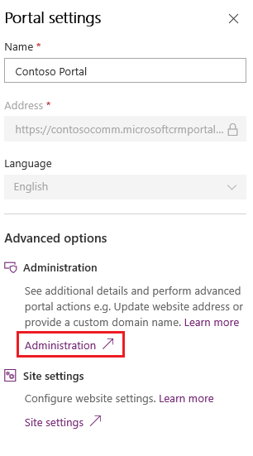

1. In the Portal settings pane, select Administration.

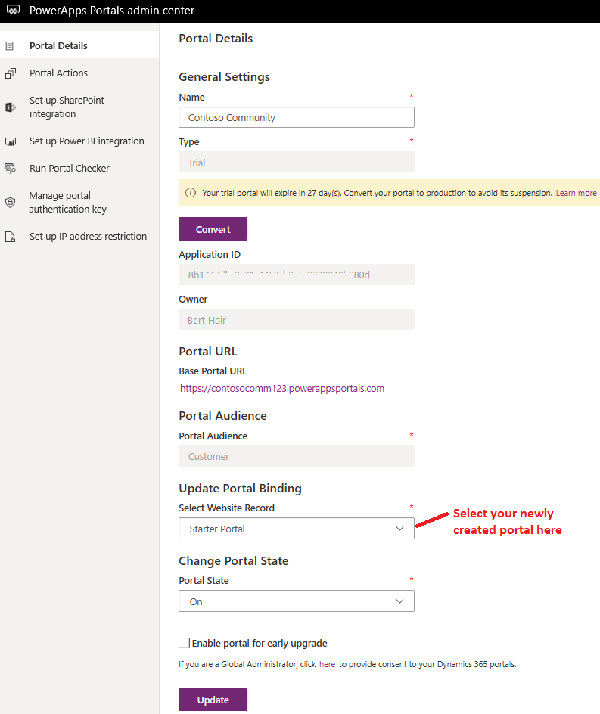

## Portal Authentication Configuration

The Dynamics 365 Manufacturing Accelerator Portal ships with a template and sample Power Automate Flow for Azure Active Directory guest authentication into the Suppler Relationship Accelerator.  This feature allows organizations already using Azure Active Directory to provision guest users in their tenant allowing them Single Sign-On experiences.  The sample application ships with a Power Automate Flow that supports the following scenario.

1. Initial Access

* Anonymous user browses site and fills out an access request
* Back office user approves access request in the model-driven application
* On approval, a Power Automate Flow uses the Office Graph API to create a guest user in the tenants AAD.  The CDS connector also creates the account, contact and questionnaire records.
* User receives an email from Azure AD with a redirect URL prompting sign-in to the portal

1. Technical and SME onboarding

* A point of contact for an account invites a SME though the “pre-approved” access request pages
* Power Automate uses the Office Graph API to create a guest user in the tenants AAD.
* User receives an email from Azure AD with a redirect URL prompting sign-in to the portal

### Prerequisites

#### Azure Active Directory Application Registration Setup

A new App Registration needs to be created, which can serve as medium to authenticate and authorize the requests between Flow and Graph API.

1. Login to Azure portal (<https://portal.azure.com/>).
2. Navigate to **Azure Active Directory** by clicking the menu on top left of the page.
   1. 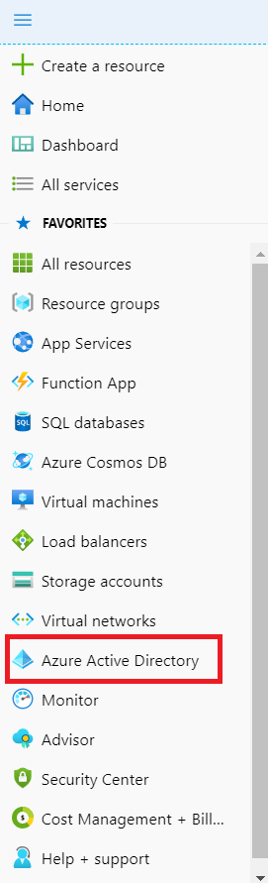
3. Select **App Registration** and then click **New Registration**
   1. 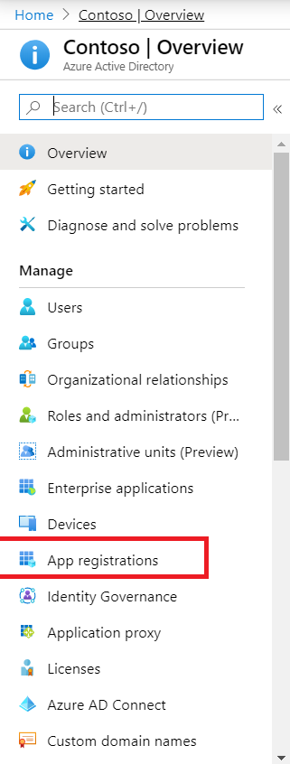
4. Enter value in **Name** field and click **Register** button.
   1. 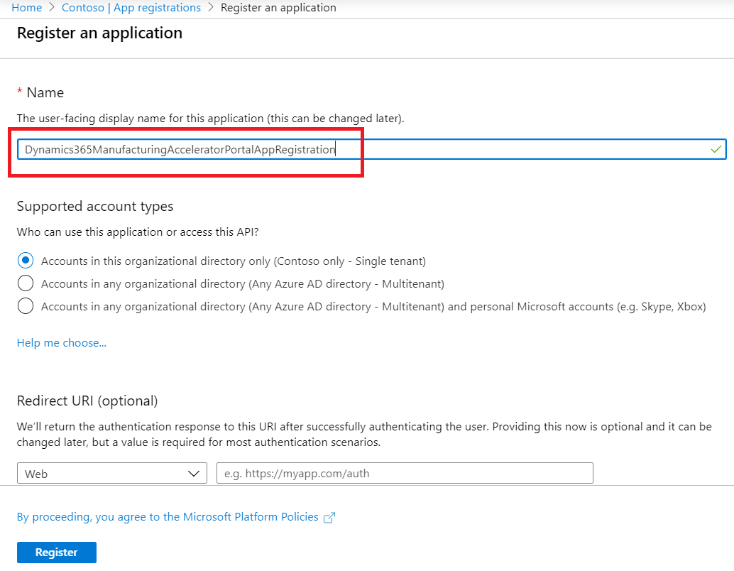
5. Set permission for Graph API
   1. Click on **API permission** and then to **Add a permission**.
   2. Select **Microsoft Graph** and then **Application Permission**.
   3. Search **user.invite**, check it and click **Add Permission** button.
   4. 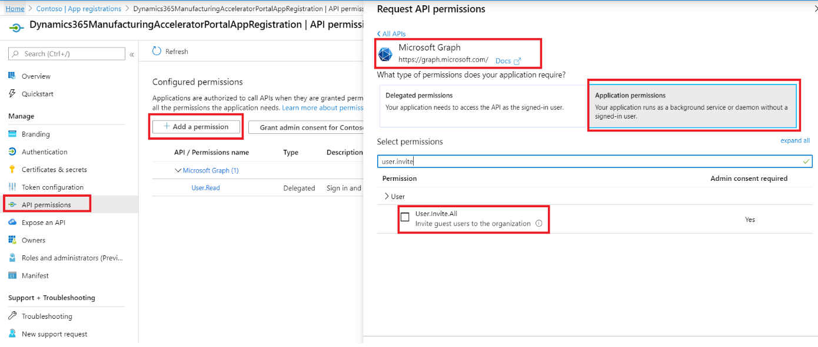
   5. Then click **Grant admin consent** button. Note: This step must be completed by Azure Admin.
6. Get Application Id and Secret Key to be used in Flow.
   1. Go to **Overview** section and copy the value of **Application ID** and save in notepad
      1. 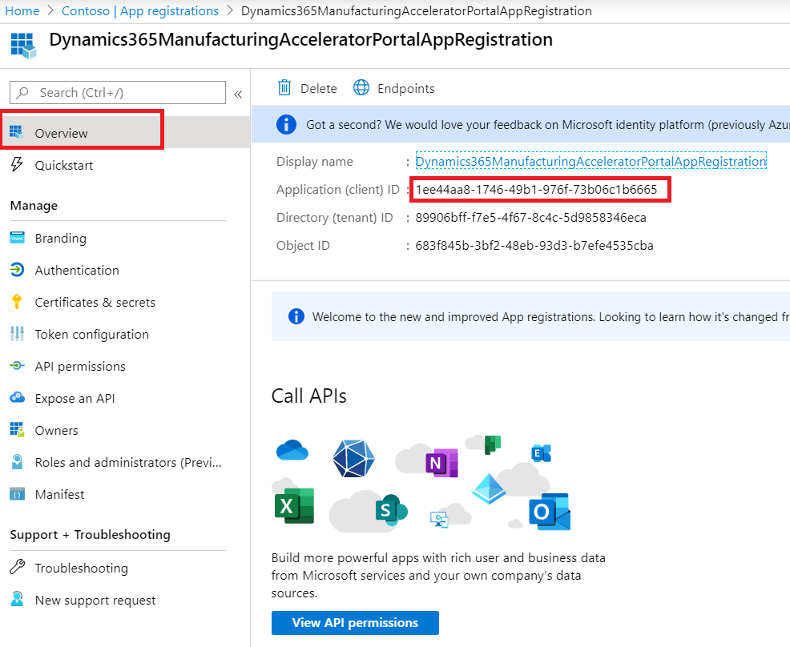
   2. Go to **Certificates & secrets**
      1. Click **New client secret** under **Client Secret**
      2. Enter value in **Description** field.
      3. Select **Never** and click **Add** button.
      4. 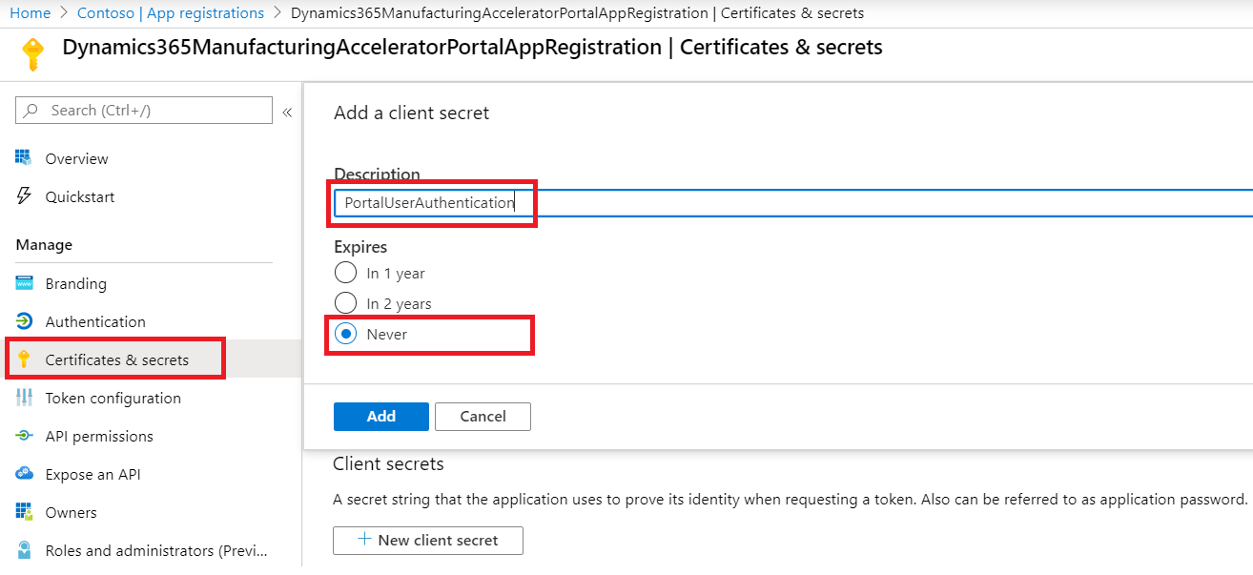
      5. Click Copy button to Copy the Value and save in notepad.
      6. 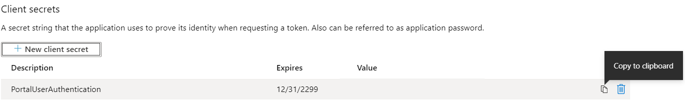

#### Configure Flow

1. Open and Edit the flow name **Access** **Request: Add User to AAD as guest and Create Vendor** found in **Dynamics365ManufacturingAcceleratorPortal** solution.
2. Update the following values
   1. SupplierURL: Update portal URL.
   2. Client: Enter Application ID noted in notepad from above.
   3. Secret: Enter secret key noted in notepad from above.
   4. Tenant: Enter Azure Active Directory Tenant
   5. DevURL: Enter portal URL
   6. SMEURL: Enter portal URL
   7. Identity provider: Enter tenant Id

Note: The above authentication approach is a sample, customers should assess all supported authentication mechanisms for their organization and make the right selection based on security, administration needs and price. To learn more about the authentication methods supported by Power Portals please see the link below.

<https://docs.microsoft.com/en-us/powerapps/maker/portals/configure/configure-portal-authentication>

## Power BI Integration

The Dynamics 365 Manufacturing Accelerator is shipped with two Power BI reports namely **Admin** and **Manager Dashboards**. The user can customize these reports as per there needs and add to either Model driven app or portal.

### Prerequisites

In order for Power BI reports to show in Model driven app and Portal, follow this [link](https://docs.microsoft.com/en-us/powerapps/maker/portals/admin/set-up-power-bi-integration#enable-power-bi-visualization).

### Model Driven App

In order to view Power BI Dashboards, open the Model driven app. Go to **Reporting** and click **Power BI dashboard** under **New** button. And select **workspace** and **dashboard** to add here.

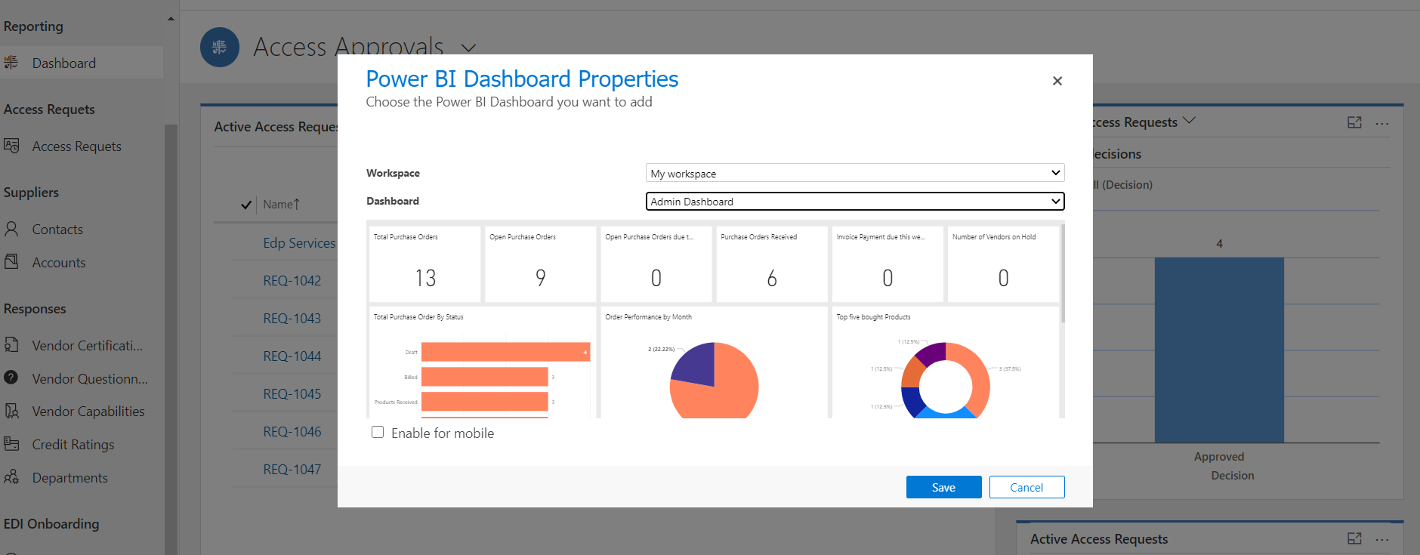

### Portal

After the Power BI integration settings are enable, we can use liquid tags to show Power BI reports embedded in a web page. For reference see this [link](https://docs.microsoft.com/en-us/powerapps/maker/portals/admin/add-powerbi-report).

# Reference

## Data Migration Utility (Configuration Migration)

The document explains how to import data to Microsoft Dynamics 365 CRM using the “Data Migration Utility”, which should be downloaded before starting the import process.

To download the tool please refer to the following link: <https://www.nuget.org/packages/Microsoft.CrmSdk.XrmTooling.ConfigurationMigration.Wpf>

To run the tool, once downloaded, extract the files and double click on the application named “DataMigrationUtility.exe”.

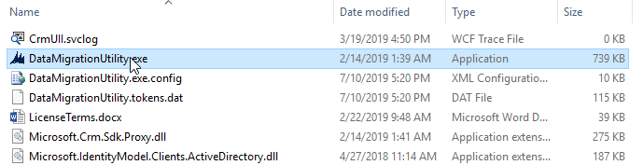

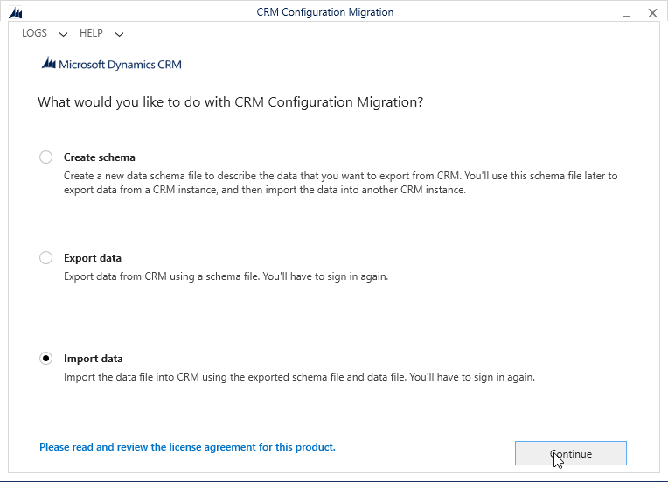

Provide the user and password for the environment that you want to import the data and press “Login”. Note that you may need to change the “Deployment Type” and “Online Region” based on the environment that you are using.

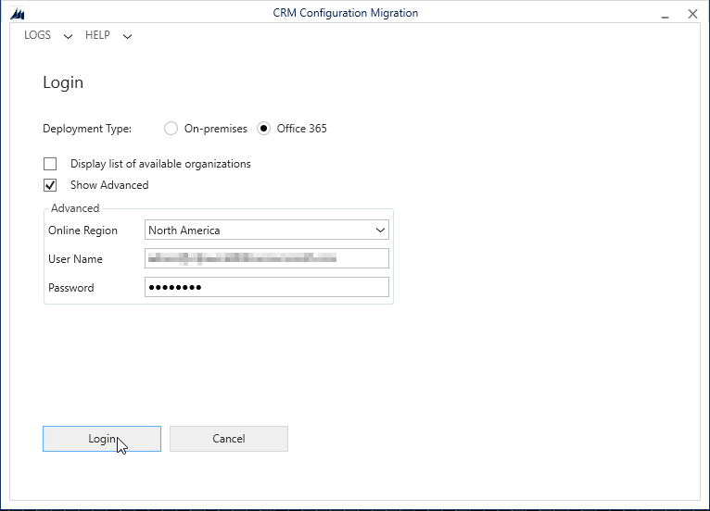

Once authenticated, click on the search button to search for the sample data package.

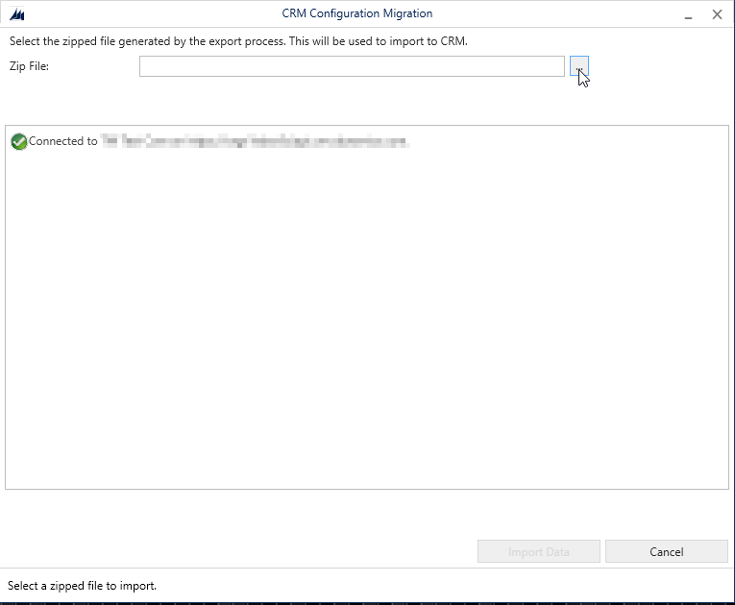

A search window will appear. Locate and select the previously downloaded data package and press “Import Data” to begin the import process.

